Directions: Complete the following tasks to create a brochure to review Genetics

Page 1 (Inside the cover):
Create a T-chart with the vocabulary terms on one side and the definitions on the other. The terms are below:

- Heredity
- Trait
- Gene
- Genotype
- Phenotype
- Dominant
- Recessive
- Allele
- Homozygous
- Heterozygous
- Probability

Page 2: Mendelian Genetics
- Include two complete sentences about Gregor Mendel and what he discovered.
- Define the following
  - Law of Dominance
  - Law of Independent Assortment
  - Law of Segregation
- Create a T-chart. Label one side “heterozygous” and label one side homozygous. Then make up four examples of each (use which ever letters you want)
  - Put a * next to the genotypes that are “purebred”
  - Put a + next to the genotypes that are “hybrid”

Page 3: Punnett Square Practice
Copy the table below and then indicate the phenotype for the (a)- (e) below
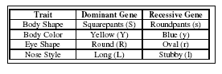
(a) LL
(b) Yy
(c) ss
(d) RR
(e) ll

Create a Punnett square to show the cross between a heterozygous Squarepants and a Roundpants, and then answer the questions.
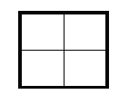
a. What is the ratio of Squarepants to Roundpants?
_______ Squarepants : ________ Roundpants

- What is the genotype of the Squarepants children? _________
- What is the genotype of the Roundpants children? _________

Pages 4 – 6 (on the back): Non-Mendelian Traits
Use the notes and/or the internet to complete the following:
- Explain and give an example of Incomplete Dominance
- Explain and give an example of Codominance
- Explain and give an example of polygenic inheritance
- Explain and give an example of a sex-linked trait

